Microsoft Azure - Starter Kits for Partners

Architecture
Archiving and Backup

Last Update: September 2015




MICROSOFT MAKES NO WARRANTIES, EXPRESS, IMPLIED OR STATUTORY, AS TO THE INFORMATION IN THIS DOCUMENT.
The information contained in this document represents the current view of Microsoft Corporation on the issues discussed as of the date of publication. Because Microsoft must respond to changing market conditions, it should not be interpreted to be a commitment on the part of Microsoft, and Microsoft cannot guarantee the accuracy of any information presented after the date of publication.
Complying with all applicable copyright laws is the responsibility of the user. Without limiting the rights under copyright, no part of this document may be reproduced, stored in or introduced into a retrieval system, or transmitted in any form or by any means (electronic, mechanical, photocopying, recording, or otherwise), or for any purpose, without the express written permission of Microsoft Corporation.
Microsoft may have patents, patent applications, trademarks, copyrights, or other intellectual property rights covering subject matter in this document. Except as expressly provided in any written license agreement from Microsoft, the furnishing of this document does not give you any license to these patents, trademarks, copyrights, or other intellectual property.
The descriptions of other companies’ products in this document, if any, are provided only as a convenience to you. Any such references should not be considered an endorsement or support by Microsoft. Microsoft cannot guarantee their accuracy, and the products may change over time. Also, the descriptions are intended as brief highlights to aid understanding, rather than as thorough coverage. For authoritative descriptions of these products, please consult their respective manufacturers.
© 2015 Microsoft Corporation. All rights reserved. Any use or distribution of these materials without express authorization of Microsoft Corp. is strictly prohibited.
Microsoft and Windows are either registered trademarks of Microsoft Corporation in the United States and/or other countries.
The names of actual companies and products mentioned herein may be the trademarks of their respective owners.

Contents
Overview 4
Account & Subscription Management 4
Choosing a Backup or Archiving Service 4
Architecture Description 5
Microsoft Azure Backup 5
DPM integrates with Microsoft Azure Backup 5
Windows Server integrates with Microsoft Azure Backup 7
Blob Snapshot 8
Distribute File System 9
SQL Server Backup to Microsoft Azure Storage 10
Additional Considerations for each scenario 11
DPM Considerations 11
Blob Snapshot Remarks 12
Interoperability of Distribute File System with Azure Virtual Machines 13
Backup and Restore SQL Server Databases to/from Microsoft Azure Storage 14

Architecture for Azure Archiving and Backup

Overview
  - The purpose of this document is to include a broader discussion of concepts relevant to setting up an archiving and backup environments in Microsoft Azure.

Account & Subscription Management
For test scenarios Microsoft Partners should use the MPN Internal User Rights. Free azure credit is given each month (as opposed to Azure Free Trial subscription) which is essential for projects that will run over several months.
Once the subscription is created, the subscription owner can add co-administrators to allow them to administer resources such as virtual machines, storage and networking. Any Microsoft account can be added as co-administrator, however, only Organizational accounts from Windows Active Directory “homed” to the subscription are allowed.
The subscription owner or co-administrators can also generate and upload Management certificates to the subscription. They can distribute them to other team members that can then manage the subscription resources using Visual Studio or Powershell. The management certificates can be easily removed from the subscription when no longer required.
In general, we recommend that Organizational accounts are configured and used with the Azure subscription management. New PowerShell commands that use Azure Resource Manager require you to provide organizational account and do not work with Microsoft accounts.

Choosing a Backup or Archiving Service
Microsoft Azure Platform offers different options to data backup or data archiving: Azure Backup, Blob Storage Snapshot or File Server based on Azure VM’s and DFS (Distributed File System).
Azure Backup manages cloud backups through familiar tools in Windows Server, Windows Server Essentials, or System Center Data Protection Manager.
Blobs are used to store unstructured binary and text data. You can create a snapshot of a blob. A snapshot is a read-only version of a blob that's taken at a point in time. Once a snapshot has been created, it can be read, copied, or deleted, but not modified. Snapshots provide a way to back up a blob as it appears at a moment in time.
Distribute File System basically consists of two major technologies: DFS Namespaces enable you to group shared folders on different file servers into a common namespace, so clients can access the distributed data using a common name and do not have to be aware of the actual location of the data. DFS Replication allows to keep folder content on different servers in sync using an efficient replication mechanism (Remote Differential Compression). Combining both technologies will allow us to implement a highly available file sharing architecture in Microsoft Azure.
SQL Server Backup to Microsoft Azure Storage, the SQL Server backup and restore component provides an essential safeguard for protecting critical data stored in your SQL Server databases. To minimize the risk of catastrophic data loss, you need to back up your databases to preserve modifications to your data on a regular basis. A well-planned backup and restore strategy helps protect databases against data loss caused by a variety of failures. With SQL Server and Microsoft Azure, you can safely backup your databases in the cloud using a Microsoft Azure Storage.

Architecture Description

Microsoft Azure Backup
As we mentioned Microsoft Azure backup offers familiar tools in Windows Server, Windows Server Essentials, or System Center Data Protection Manager to provide a cloud backup service.

DPM integrates with Microsoft Azure Backup
The purpose of this section is explain each component of the architecture for Microsoft Azure Backup scenarios, the first one is integrated with System Center Data Protection Manager, you can store backed up data for short-term storage to tape, to disk, or to a combination of disk and Microsoft Azure. With backup to Azure enabled, your disk-based replicas are backed up to Azure storage.
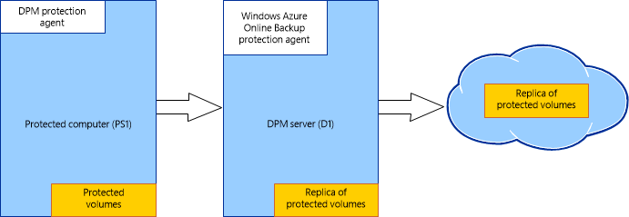
Figure 1. Microsoft Azure Backup integrates with System Center Data Protection Manager
You can store backed up DPM data in Azure as follows:
Scenario 01 - DPM deployed as physical server or on-premises virtual machine— (Figure 2) If you deploy DPM as a physical server or as an on-premises virtual machine in Hyper-V you can select to back up data with Azure Backup in addition to backing data up to disk for short-term storage.
Figure 2. DPM deployed as physical server or on-premises virtual machine
Scenario 02 - DPM deployed as Azure virtual machine—On System Center 2012 R2 with Update 3, DPM can be deployed as an Azure virtual machine. In this deployment, you can back up data to Azure disks attached to the DPM Azure virtual machine, or you can offload data storage by backing it up with Azure Backup.
Figure 3. DPM deployed as Azure virtual machine

Scenario 03 - Windows Server integrates with Microsoft Azure Backup - Windows Server Essentials provides reliable ways to perform regular backups of your server and backups of your network computers. In the event of data loss, you can restore data from a successful backup on the server without restoring the entire computer. If necessary, you can perform a full system restore to your server or client computers in the network.
Windows Server Essentials is now available in two forms:
- As a server role: Windows Server Essentials Experience is provided as a server role in the Standard and Datacenter editions of Windows Server 2012 R2. Installing Windows Server Essentials Experience in Windows Server 2012 R2 provides you with all the features and functionalities (such as the Dashboard, client computer backups, and Remote Web Access) of Windows Server 2012 R2 Essentials without the locks and limits that are imposed on it. For more information about this new server role, see Windows Server Essentials Experience Overview.
- As a core Windows Server edition: Windows Server 2012 R2 Essentials. As a part of your installation process, you can opt to install Windows Server 2012 R2 Essentials as a virtual machine by following instructions in a wizard.
The following table describes the backup integration with Microsoft Azure Backup available to you along with their advantages and the basic architecture is described in the Figure 4.
Backup Feature | Description | Advantages
Microsoft Azure Backup | Performs an online backup of files or folders on your server. When you use Azure Backup to back up server data, the information is encrypted by using your passphrase before it is uploaded to a secure datacenter on the Internet.  For more information, see Manage Online Backup in Windows Server Essentials. | - Can restore files and folders from your server.  - With incremental backups, only changes to files are transferred to the cloud.  - Backups are stored in Microsoft Azure and are offsite, reducing the need to secure and protect onsite backup media.

Figure 4. Microsoft Azure Backup with Windows Server and Windows Client Agent Architecture

Scenario 04 – Microsoft Azure Backup Server deployed as physical server or on-premises virtual machine— (Figure 5) If you deploy Microsoft Azure Backup Server as a physical server or as an on-premises virtual machine in Hyper-V you can select to back up data with Azure Backup in addition to backing data up to disk for short-term storage.
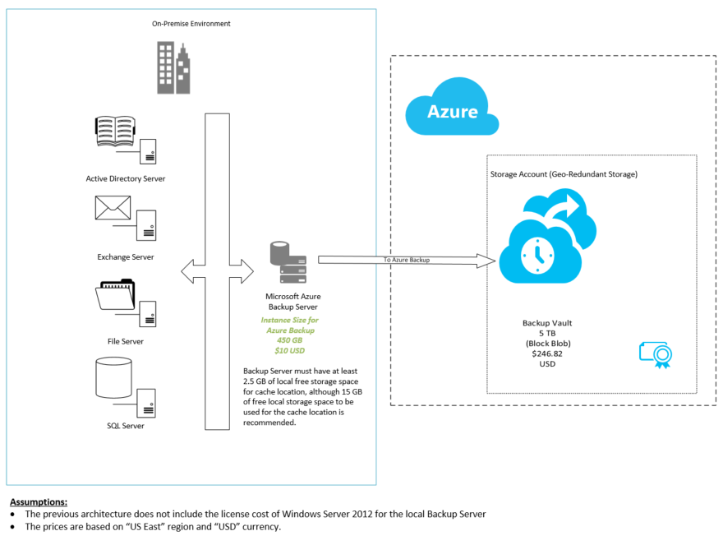
Figure 5. Microsoft Azure Backup Server deployed as physical server or on-premises virtual machine

Blob Snapshot

Note that while Azure Storage provides data resiliency through automated replicas, this does not prevent your application code (or developers/users) from corrupting data through accidental or unintended deletion, update, and so on. Maintaining data fidelity in the case of application or user error requires more advanced techniques, such as copying the data to a secondary storage location with an audit log. Developers can take advantage of the blob snapshot capability, which can create read-only point in time snapshots of blob contents. This can be used as the basis of a data-fidelity solution for blobs.
For Azure Blobs, you can perform point-in-time backups using the blob snapshot feature. For each snapshot, you are only charged for the storage required to store the differences within the blob since the last snapshot state. The snapshots are dependent on the existence of the original blob they are based on, so a copy operation to another blob or even another storage account is advisable to ensure that backup data is properly protected against accidental deletion.
The architecture below includes the components for Blob Snapshot (Figure 6)
Figure 6. Blob Snapshot Architecture

Distribute File System
To leverage Distribute File System Replication (DFS-R), there are a couple dependencies that we’ll need to keep in mind prior to configuring DFS-R:
- Site-to-Site connectivity: there needs to be a direct connection between sites for DFS-R to communicate between servers. Typically this is accomplished via either a WAN connection or a Site-to-Site VPN connection.
- Active Directory: Like many applications, DFS-R also depends on Active Directory. To support DFS, we will want to extend our Active Directory forest with local domain controllers at the DR site, the same way that we’d extend Active Directory to a branch office location.
The architecture below describe each component of Hybrid Cloud–Enable Distributed File System (DFS) in Microsoft Azure for a Small File Server:
Figure 7. Distributed File System Replication for a Small File Server in Azure

SQL Server Backup to Microsoft Azure Storage
One of the fundamental administrator tasks is backing up and restoring databases. With SQL Server and Microsoft Azure, you can safely backup your databases in the cloud.
The key benefits of using the backup and restore capabilities of SQL Server with Microsoft Azure Storage as a backup destination include:
- Limitless low-cost storage
- Highly available storage (geographically replicated to ensure no data loss)
- Off-site storage that can support disaster recovery and compliance requirements
- Simplified remote backup and restore process
Figure 8. Azure SQL Database Architecture

Additional Considerations for each scenario

DPM Considerations
- You can back up the following workloads to Azure:
  - File data
  - Hyper-V virtual machines
  - SQL Server databases
- Supported file types include:
  - Encrypted (Full backups only)
  - Compressed (Incremental backups supported)
  - Sparse (Incremental backups supported)
  - Compressed and sparse (Treated as Sparse)
Unsupported file types include:
  - Hard links (Skipped)
  - Reparse points (Skipped)
  - Encrypted and compressed (Skipped)
  - Encrypted and sparse (Skipped)
  - Compressed stream
  - Sparse stream

- DPM servers on case-sensitive file systems are not supported.
- DPM must be running on a server installed with Windows Server 2012 R2, Windows Server 2012, or Windows Server 2008 R2 with SP1. The DPM version must be DPM in System Center 2012 SP1 or System Center 2012 R2.
- You’ll need to install the Azure Backup Agent on the DPM server. The server will need at least 2.5 GB of local free storage space for cache location. Although 15 GB is recommended.
- You’ll need a management certificate that you’ll upload to the backup vault in Azure for authentication purposes.
  - To upload to the certificate to the vault, you’ll need to export it as a .cer format file that contains the public key.
  - The certificate should be an x.509 v3 certificate.
  - The key length should be at least 2048 bits.
  - The certificate must have a valid ClientAuthentication EKU.
  - The certificate should be currently valid with a validity period that does not exceed 3 years.
  - The certificate should reside in the Personal certificate store of your Local Computer.
  - The private key should be included during installation of the certificate.

Blob Snapshot Remarks
Snapshots provide read-only versions of blobs. Once a snapshot has been created, it can be read, copied, or deleted, but not modified.
A snapshot provides a convenient way to back up blob data. You can use a snapshot to restore a blob to an earlier version by calling Copy Blob to overwrite a base blob with its snapshot.
When you create a snapshot, the Blob service returns a DateTime value that uniquely identifies the snapshot relative to its base blob. You can use this value to perform further operations on the snapshot. Note that you should treat this DateTime value as opaque.
The DateTime value identifies the snapshot on the URI. For example, a base blob and its snapshots have URIs similar to the following:
- Base blob: http://myaccount.blob.core.windows.net/mycontainer/myblob
- Snapshot: http://myaccount.blob.core.windows.net/mycontainer/myblob?snapshot=<DateTime>
Note that each time you call the Snapshot Blob operation, a new snapshot is created, with a unique DateTime value. A blob can support any number of snapshots. Existing snapshots are never overwritten, but must be deleted explicitly by calling Delete Blob and setting the x-ms-include-snapshots header to the appropriate value.

Interoperability of Distribute File System with Azure Virtual Machines
Using DFS Namespaces and DFS Replication on a virtual machine in Azure has been tested with Windows Server 2012 R2; however, there are some limitations and requirements that you must follow.
For DFS Namespaces:
- You can’t cluster stand-alone namespaces in Azure virtual machines.
- You can host domain-based namespaces in Azure virtual machines, including environments with Azure AD, though a single namespace can’t encompass both on premise namespace servers and namespace servers hosted in Azure VMs, even when using Active Directory Federation Services.
For DFS Replication:
- Using snapshots or saved states to restore a server running DFS Replication for replication of anything other than the SYSVOL folder causes DFS Replication to fail, which requires special database recovery steps. Similarly, don’t export, clone, or copy the virtual machines. For more information, see article 2517913 in the Microsoft Knowledge Base, as well as Safely Virtualizing DFSR.
- When backing up data in a replicated folder hosted in a virtual machine, you must use backup software from within the guest virtual machine.
- DFS Replication requires access to physical or virtualized domain controllers – it can’t communicate directly with Azure AD.
- DFS Replication requires a VPN connection between your on premise replication group members and any members hosted in Azure VMs. You also need to configure the on premise router (such as Forefront Threat Management Gateway) to allow the RPC Endpoint Mapper (port 135) and a randomly assigned port between 49152 and 65535 to pass over the VPN connection. You can use the Set-DfsrMachineConfiguration cmdlet or the Dfsrdiag command line tool to specify a static port instead of the random port. For more information about how to specify a static port for DFS Replication, see Set-DfsrServiceConfiguration. For information about related ports to open for managing Windows Server, see article 832017 in the Microsoft Knowledge Base.

Backup and Restore SQL Server Databases to/from Microsoft Azure Storage
SQL Server supports storing backups to the Microsoft Azure Blob storage service in the following ways:
Manage your backups to Microsoft Azure: Using the same methods used to backup to DISK and TAPE, you can now back up to Microsoft Azure storage by Specifying URL as the backup destination. You can use this feature to manually backup or configure your own backup strategy like you would for a local storage or other off-site options. This feature is also referred to as SQL Server Backup to URL. For more information, see SQL Server Backup to URL. This feature is available in SQL Server 2012 SP1 CU2 or later.
Note
For SQL Server versions previous to SQL Server 2014, you can use the add-in SQL Server Backup to Microsoft Azure Tool to quickly and easily create backups to Microsoft Azure storage. For more information, see download center.
Let SQL Server Manage backups to Microsoft Azure: Configure SQL Server to manage the backup strategy and schedule backups for a single database, or several databases, or set defaults at the instance level. This feature is referred to as SQL Server Managed Backup to Microsoft Azure. For more information see SQL Server Managed Backup to Microsoft Azure. This feature is available in SQL Server 2014 or later.
More information about backup options:
- The SQL Server Backup to URL feature enables you to back up to Microsoft Azure Storage by specifying URL as the backup destination. With this feature, you can perform a manual backup or configure your own backup strategy like you would for a local storage or other off-site options.
- The Backup Encryption feature enables you to encrypt the data while creating a backup for your storage destinations: on-premises and Microsoft Azure Storage.
- The Backup Compression (SQL Server) feature enables you to create a backup, which is smaller than an uncompressed backup of the same data. Compressing a backup needs less device I/O and therefore usually increases backup speed significantly. This can bring great benefits when storing backup files in Microsoft Azure Storage.
- The SQL Server Managed Backup to Microsoft Azure feature enables you to automatically backup SQL Server databases to Microsoft Azure Storage. With this feature, you can configure SQL Server to manage the backup strategy and schedule backups for a single database, or several databases, or set defaults at the instance level.
- The SQL Server Backup to Microsoft Azure Tool enables backup to Microsoft Azure Blob Storage and encrypts and compresses SQL Server backups stored locally or in the cloud. This tool enables a single cloud backup strategy across for several versions of SQL Server, such as SQL Server 2005, 2008, 2008 R2, and 2014.

